IOT Smart Lighting System

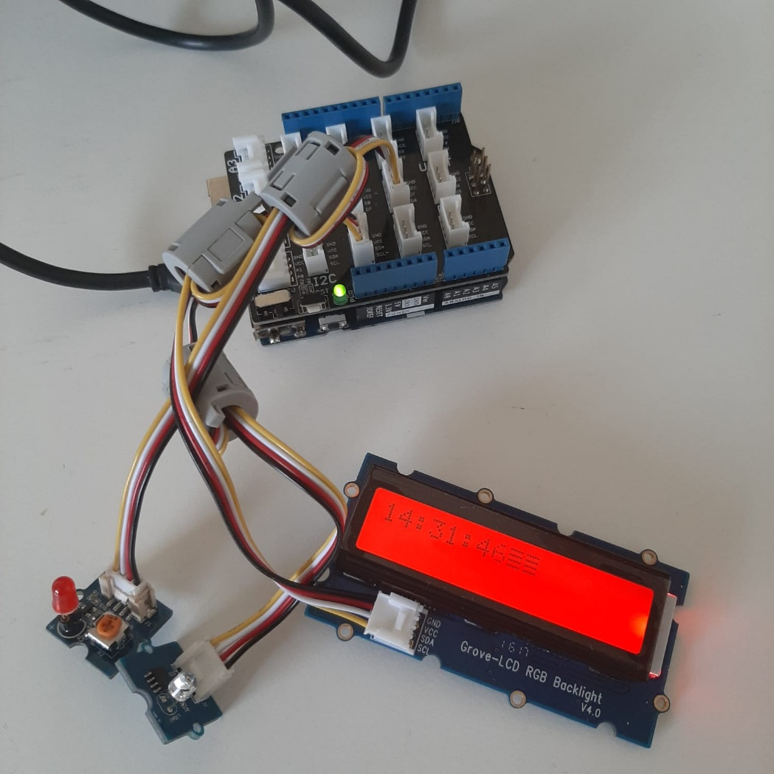

**Group Members:**

Paul Mulvaney (Mulvaney.Paul@mail.itsligo.ie) : Problem to be solved, Project Solution  
Martin Melody (Martin.Melody@mail.itsligo.ie) : Project Requirements, Initial Design  
Aaron Houston (Aaron.Houston@mail.itsligo.ie) : Implementation Plan  
Kieran Boyle (Kieran.Boyle@mail.itsligo.ie) : Testing; Security and future Improvements

**Links:**

Trello Page: : https://trello.com/b/3eBxkrN8/iot-board

GitHub Team Page: : https://github.com/AaronH18/IoTSmartLight

Presentation : https://mailitsligo-my.sharepoint.com/:p:/g/personal/s00211628_mail_itsligo_ie/EVegqB4ltBVAkh1q3tdNn9YBVNADSRFxwSHq79_Wd699Zw?e=bwdMPA

Problem to be solved

For this project the problem we are trying to solve is relatively simple. To help ease strain and improve productivity and mental health of computer users by keeping them in a well-lit, and productive environment through the use of a dynamic lighting system. Using a lighting system that will automatically adjust to the users’ needs by adjusting the colour temperature and brightness of the light in their office based on the time of day and the amount of natural light filtering into the workspace. By adjusting the brightness, we hope to keep the user’s workspace at a similar level of brightness throughout their day. While also using an internal clock, we hope to keep the colour temperature of this light at the optimal level depending on the time of day. Thereby negating some of the effects of blue light on the user’s eyes, sleep patterns and mental health.

For the past year due to Covid-19 many business, schools and colleges have pivoted to a work from home model. While some people’s workflow is entirely unimpeded, the reality for most is that they are now working in an area that was never intended to be used as a permanent office. This has led to a number of people working in workspaces that could be more damaging to themselves than they potentially realise. The cold blue light given off by computers, smartphones and other devices has been linked to a number of health issues. And being unaware and not taking the correct precautions can worsen the situation for a user. What we aim to provide is a lighting system that can be used in a number of forms to provide the user a safer and more productive workplace. We hope that this will also provide the user with an overall better improvement of mental health over time.

The focus of the project in the first iteration was to focus on getting a working prototype that would display the functions we are hoping for in a finished product. On this version we were hoping to get the product fully working over the internet and using a smart bulb. This is much more representative of what a finished product would look like. Our idea for a fully realised product would have the user buy this product pair it to a smart light and then the system could work passively while they work.

Summary of Project Solution

As with our first version of this product, our end goal with this project is to create an automatically adjusting lighting system that will keep the user a recommended level of light throughout the day. Keeping the user in a well-lit environment is the simplest problem. Using a light sensor, we will be able to read in the value of light within the room. Using this value against a tested recommended level we will be able to raise or lower the brightness of the light as needed as the day goes on.   
The next part of the solution is the colour temperature. We are hoping to negate negative effects of blue light exposure on the use throughout the day. This will be achieved by adjusting the colour temperature of the as the day goes on progressively going from blue at the start of the workday to a more-soft yellow, orange tone. By reading from the user’s pcs internal clock we can thereby find the current time and adjust the colour temperature as needed.  
On this iteration we are using a Philips smart bulb as our final output. This gives us much more flexibility in term of how simply we can solve these solutions. As the bulb already has auto brightness and colour changing features, we are able to easily control and adjust the bulb to suit our needs.

**Rough illustration of proposed solution.**

As our system is using the same light sensor as before there isn’t much necessary work to adjust on the code of the solution with the difference being that we would be call from an API to control our bulb instead of triggering an internal LED. Because we can use an existing code structure for our light turning on and off and switching the LED colour, we are already solving all the solutions for our first iteration of this prototype.

The real challenge in this project is getting the smart build to be triggered by the Arduino. Fortunately for our build of this project as out light we chose a Philips smart bulb that can be connected over the internet and is already programmed to be triggered by external calls from a companion app.   
What we doing is using an API called IFTTT this is an online platform that can be used to control many smart devices. This makes the design of the product much simpler. Where we on the previous product were using the led in an on or off state, we can simply just replace this with an API call that says to turn on and off the bulb.

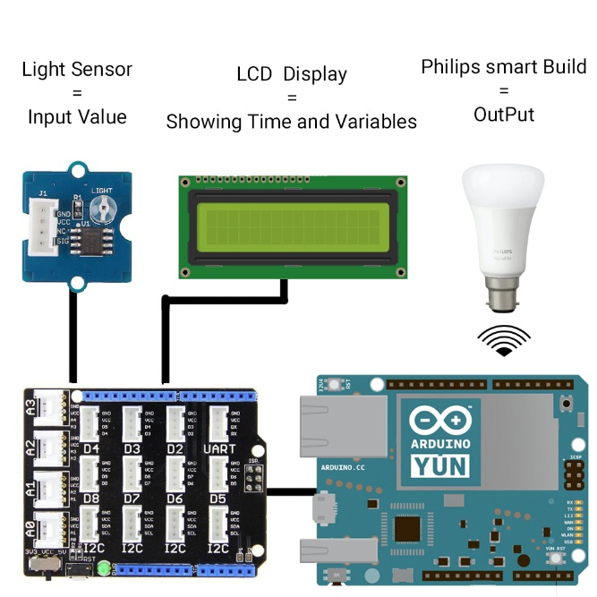

**Comparison Of first and second iteration.**

As you can see from the above hardware designs the idea has remained very similar to the original. But has been greatly improved though the use of the IFTTT API. This also allows the user to buy a light the suits them better. i.e. Lamp, overhead light or possibly an LED strip. As long as they have internet connectivity, we can use this API to trigger them. This expands our functionality as well as increasing the customer base for this product.

# Requirements & Initial Design

# Old Requirements

1. This object should be as compact as a normal desk lamp so it will not take up too much space on desks.
2. The lamp needs to be able to detect the time of day and adjust the temperature accordingly.
3. Display information in the LCD.
4. Have a focus mode to help with productivity. (For final design)
5. It needs to look pleasing on a desk. (For final design)
6. Needs to read the light level in the room.

# New Requirements

1. This object should be as compact as possible.
2. The lamp needs to be able to detect the time of day and adjust the temperature accordingly.
3. Display information on the LCD.
4. Look pleasing on the desk.
5. Integrate API functionality

# Design

 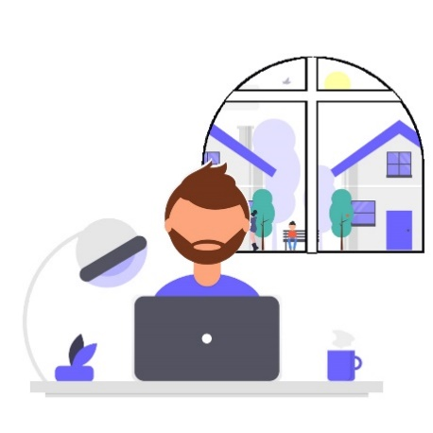

The design has stayed basically the same. Using the API we were able to separate the bulb from the arduino, which would allow us to keep the design looking better being able to make the lamp look nice without having to figure out how to intigate the arduino with all its wires and sensors into the lamp or the light. Now the light bulb can be controled from anywhere aslong as there is an internet conection.

# Code Design

The functions that we need this device to be able to do are:

* Check and display the time onto the LCD
* Change the brightness of and colour of the Smart Blub.
* Communicate with the API

# 

# Checking the Time

Since our code for checking the time worked so well in the last project we didn’t’ have to change anything about it.

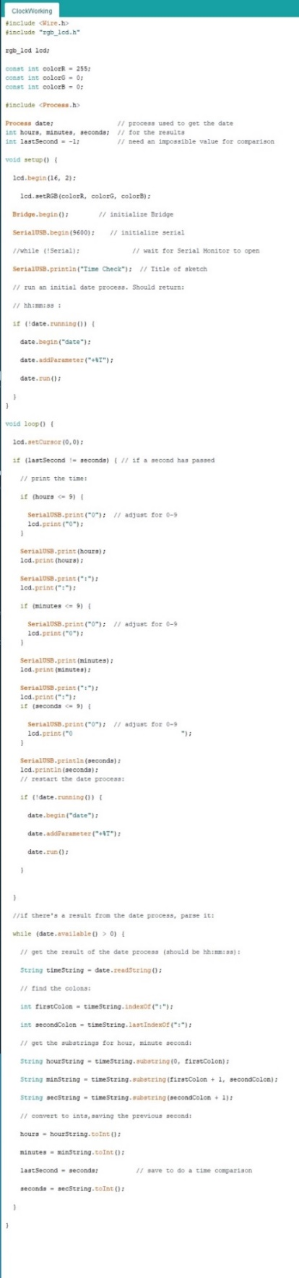

# Controlling the Smart Light

We found this code online That would allow us to communicate with the software designed to modify the temperature and colour settings of the smart light using the API If This Then That (ITTT).

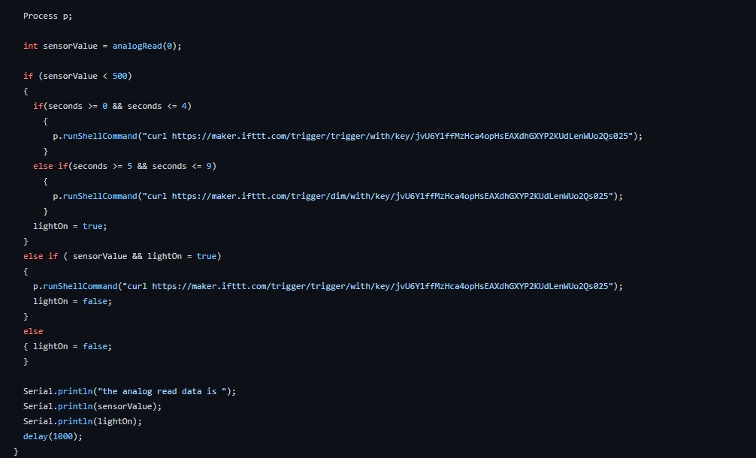

# hardware setup

The hardware we used for the projects was:

* Base Shield
* LCD RBG Backlight
* Philips Smart Light
* Light Sensor
* Wires

Implementation Plan

Our smart light was still designed with the target audience of students and those who work at home for many hours. We keep our clock feature the same as it worked perfectly, and it helps keep the product more attractive to our target audiences.

Most people have messy desks and with our older version we added to that clutter with a lamp, so with our newer design we focused on a lightbulb rather than a lamp.

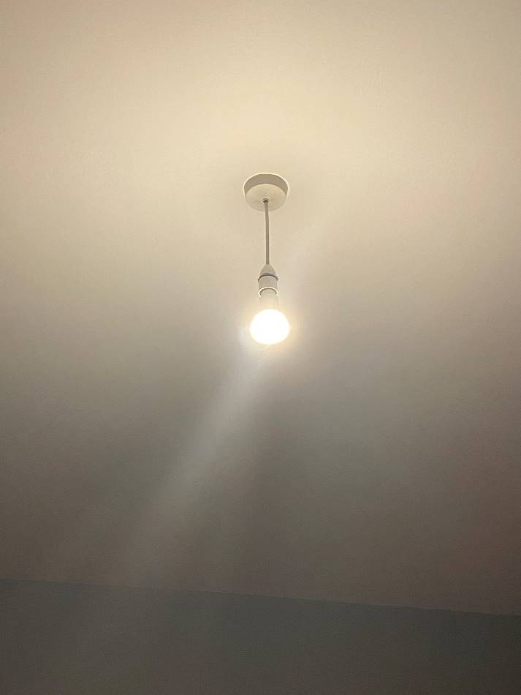

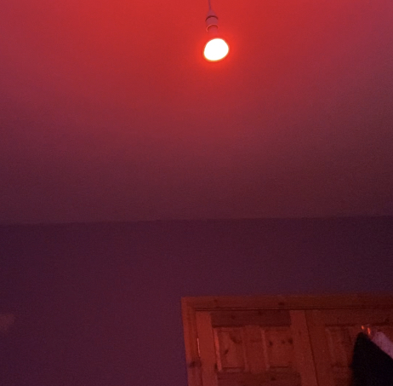

The great thing about our updated design is that it still does not require many parts to function

Parts List

* Laptop / Desktop PC
* Arduino Yun
* Light Sensor
* LCD Screen
* Internet Access
* Philips Hue Light Bulb

No additional equipment was needed other than the “Grove Kit” + The Smart Bulb

We are using an API called If this then that which allowed us to connect the lightbulb to it and setup a webhook that can be triggered by the Arduino and get the light bulb to do the specific functions we have told it to do.

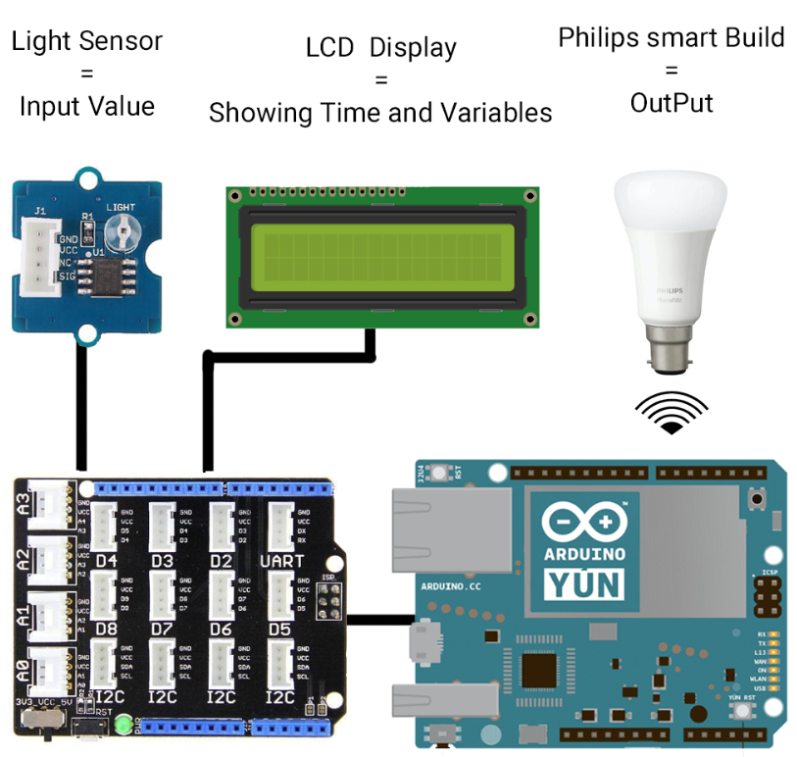

Code Samples

This is a sample of our code which runs a loop that will turn the light on and off every 5 sections, This was make sure the base code was working before it was added upon and also to test the light bulb triggers to make sure they were working as attended

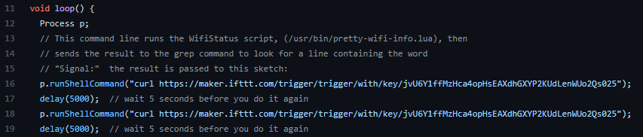

This section triggers each webhook allowing the light to change colour or turn on/off:

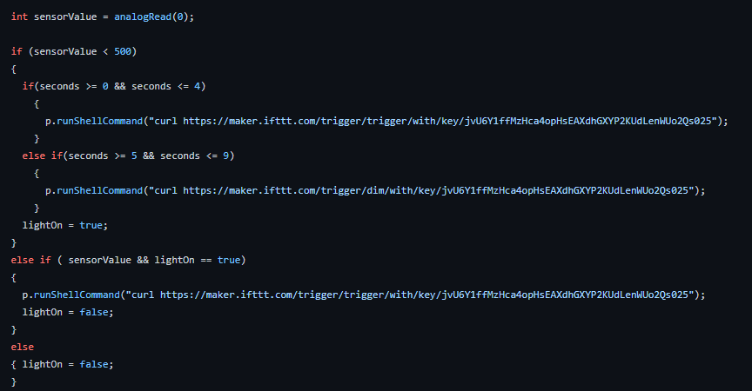

This is what tells the Arduino the time so it can display it on the LCD Screen:

# 

Testing

Getting to testing took some time but we eventually got there, the first thing we decided to do was have a group meeting to decide on the best and most practical way for us to test a group. The group decided the best way to be fair would be to each to some of the code individually and later we could test it on the hardware as a group or individually. We would keep each other informed of any work done in the WhatsApp group we have and then updates would be posted to both the Trello and GitHub pages. The first test run we done was unsuccessful we used a breadboard several led lights, resistors, and wires along with the Arduino Yun and grove kit. For the second test we decided to remove the breadboard and use the Arduino, grove kit, led socket and light sensor. This test went a little better the led worked and was responsive to the sensor, the led was in port 12 and the sensor was in A0 and there was no reading from the serial monitor. We decided we would like to make further improvements and add a clock to the project which required us to add some more code. This time our testing was not fully successful we got the clock working but the LED light was constantly lit and unresponsive to the sensor. Back to the drawing board which required us to tweak the code slightly and once we tested it further it looked like we had it. We then noticed the clock would stop working once the led was plugged in. once again we made some small changes to the code changing the led IN to port six, leaving the clock in port twelve and the sensor in the A0 port. Success, the led was fully responsive to the sensor and the clock was reading in the correct time. When we opened the serial monitor, we could see the sensor was responsive to the different levels of light which it previously wasn’t which was what we had hoped to achieve. It took a little longer than expected to get there but it was a little expected at the same time, we kept chipping away at it as a team and got the desired result in the end.

Project Two

The challenge of testing this time was somewhat different as Aaron had the smart bulb and we were trying to light it from a different location. To overcome the challenge of testing Aaron would turn on his webcam as we ran the code and we could see the effects happen if any. For testing in project two Paul had sourced the code need for the smart bulb and posted it on GitHub. Paul, Martin, Aaron and I individually worked on trying to get the code to work but to no success. We then scheduled a group meeting where we met on Microsoft teams and made several attempts to get the smart bulb working using the Arduino but no success again. We had the lcd in digital port two and the light sensor in analogue three, but something was wrong. We continued working on it in the meeting and Paul then altered some of his code and ran the code while asking Aaron if the light was lit and finally it was. We then scheduled another meeting on Microsoft teams this time to test the bulb with the code while using the light sensor. As we were testing, we had some difficulty with the sensor as the light was not fully responsive. It was late that night so we decided we would postpone the testing until the next day. The next day we gave the testing another go. This time we changed the lcd screen into digital port twelve C and put the light sensor into analogue port A three. We also brought down the delay time from one thousand to eight hundred. This time when we ran the code we could see through Aaron’s camera that the light had lit up red , this was a problem as we also needed it to light up the standard yellow depending on the level of light but this was not happening. We went back and adjusted the command on IFTTT the so the light would be the standard yellow or change to red depending on the level of light the sensor was reading in. when we went back to try this out it worked the light was responsive to the sensor. The light was coming on when the sensor was covered and going off when uncovered it was also reading in the light levels from the sensor as we previously had implemented in project one. The light was red when testing during the day and the standard yellow when we tested later that night. This is what we set out to achieve. We then took a video of some further testing we done and implemented one of the videos into our presentation when we were happy with both the testing and the video we had made. As a group we feel testing this time was more inclusive as we needed each other there to test the project. In project one we could test the led and sensor as we had all the equipment in one place but with the bulb being in a different location, we had to rely on each other to get the testing done. Whether this be testing the new rest API triggers we had implemented into our code it was being done now solely over the internet which was a change. Thankfully we got our testing complete with the new API and light sensor being responsive, so we were ready to start preparing for the presentation.

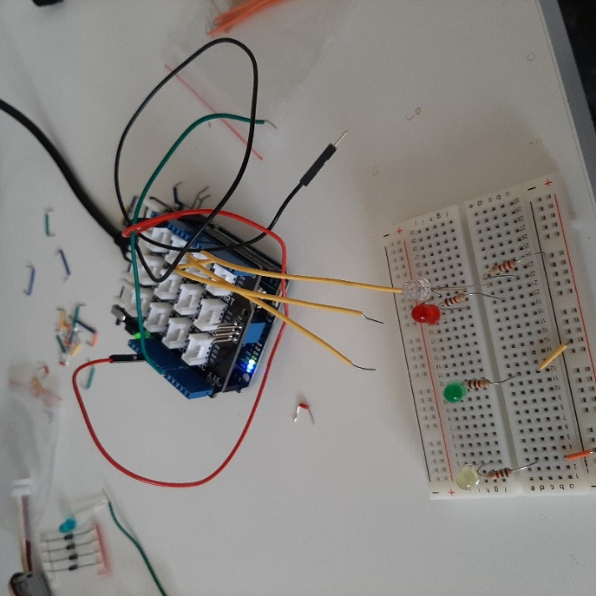 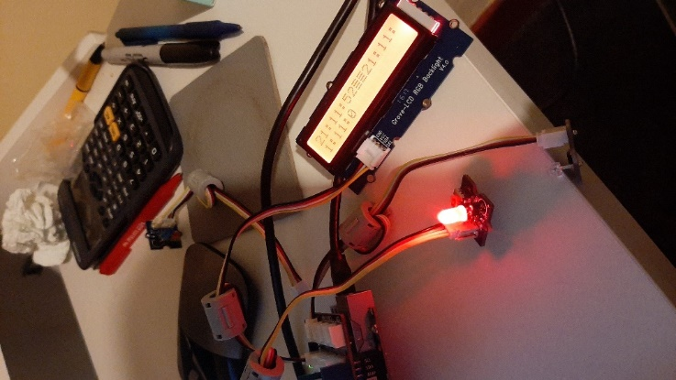

2nd test partial success clock works but prints more than once and led is lit constantly

Security

here are so many security risks in 2021 more and more often we seem to hear about security breaches and people’s personal information being compromised. These days everything seems to be connected to the internet so it is important we look at what security we can implement to our project in the future to avoid any security attacks or limit some of the vulnerabilities available to target. The best and possibly most obvious place to start would be with your home Wi-Fi changing from the default password will limit access to any unauthorized users and limit some of the opportunities to attack the Arduino project or the code.

Another good option would be to use DCHP where possible to reserve the mac address to avoid the Yun being unable to access the network. It would be a smart option in my opinion to use camel casing and numbers and symbols to ensure your password is as difficult as possible for anyone to try and guess. Example Pa$sw0Rd this makes the password difficult for anyone to figure out and its recommended you do not share your password with anyone else. The Arduino Yun address 192.168.240.1. can be accessible through the hotspot so it is a good idea to make sure another strong password is used on the interface configuration website and is not left as the default password. one other way to add some protection to the project would be the use on online debugger software such as visual micro which is a plug in available via Microsoft that is used to Create cross platform programs on Arduino.

The next step I would introduce to avoid any physical security breaches such as resetting to default factory settings by pressing the WLAN RST button for longer than thirty seconds. To avoid this, I would place the Arduino Yun itself in the box pictured below then I would place it in a larger box secured with a lock to avoid any unauthorized access other than the user themselves. Project Two: For further security we have sourced the two-factor authentication on the Arduino website. This allows you to scan a QR code which gives you an authentication code that changes every thirty seconds. You will then be required to enter the code and once this is done you receive a recovery code which you must keep safe as you will need this to restore your account should you forget your password. This adds an extra layer of security which requires both your password and a six-digit pin sent to your authentication app on your mobile phone. This means should someone get your password they still need the code sent to your mobile, without this they cannot log in. we have also sourced some code which allows us to send a http request to a client and can receive data back from the client.

For added security as http is not fully secure, we have a code encryption which encrypts any data received but decided against adding it to the current project as we are only reading in light levels and not personal information or data. Some other security available is the Arduino security primer which gives access to the Arduino IoT cloud, this allows you to store code. The security primer requires a hardware element to guarantee authenticity and confidentiality and provides two further elements. Unfortunately, this requires an upgrade to a premium account as the Arduino Yun is not compatible with a basic account. For the project two as we are using a smart bulb, we are required to make commands across the internet it is very important that we use secure protocols which is why we use the https protocol when calling the light trigger from the Arduino Yun.

As previously mentioned in project one it is just as important that we change all default passwords. As the smart bulb is controlled by IFTTT (If not this then that) for added security it would be best to use the correct protocols and a strong IFTTT password for your account. It would be best to register with your google or apple account as this would inform you of any log in or activity on your account and may even need authentication to access the account. Now that we have these new steps in place, we would be more confident with the security of our project. Further security be added in the future, but we are confident that the further security we have added is a step up from the security we had in project one.

Example cases for physical security

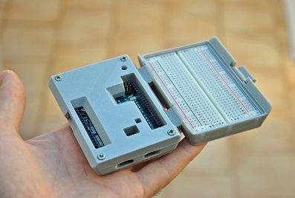 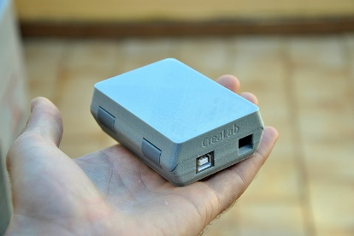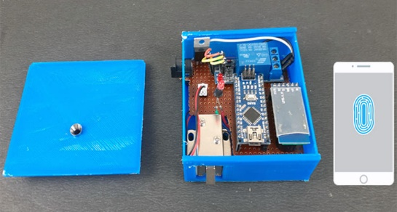

References:

<https://docs.google.com/forms/d/e/1FAIpQLSflkD2mEYdRsqyPBUQxaViIpyXmHT5KD8856fzpqEnpT3sRrA/viewform?c=0&w=1>

<https://blog.arduino.cc/2020/07/02/arduino-security-primer/>

Future

For the future of our project we plan to implement several LEDs rather than just one because we believe it would be pretty cool to see several LEDs responding to the light sensor at once. This would also give us a better idea of what it would look like as an actual lamp. Another improvement we would like to implement is the use of a website interface which would allow us to control the project from a mobile phone. This could not only be used to turn the light on and off but also perhaps also record light readings or set a timer for the light, but this would all depend on further investigation of course. we would also like to add an indicator to let the lamp tell the person how long they have been sat in their workstation and when it is time to take a break. There are already some websites and applications to do this for smart bulbs so we believe this could be added to our project.

For future possibilities this could be used in office lighting where people are working long hours so they do not have to worry the lasting effects the lighting could have on their eyes. Another area it would work would be in schools and colleges where students are also studying for long hours and laptops are becoming a bigger part of education each day. An area it could also be implemented is in the use of car headlights so the lighting would not have a damaging effect on the eyes of not just drivers on long journeys but also professional drivers such as lorry drivers or delivery drivers.

The scope for ideas is large where it could be used in such areas as shopping centers, flashlights, phone and laptop screen lighting all which could benefit peoples eye health and mental health which studies have proven. As a group an area we would also like to investigate for the current project would be energy efficiency, to make our project perform the same task while using less energy to perform the same task. This would also benefit some of the future possibilities mentioned earlier as it could assist us in getting as low an energy as possible to make it environmentally friendly.

We would also look at the possibility of adding some more sensors and another screen to the project which would read temperature and humidity of the workspace area. As we would like to have mobile phones controlling the light, we could also investigate perhaps adding a USB port to the project so the user could connect other devices such as phones or other smart devices. It would also be interesting to see if the project could be connected to a dimmer switch in the home which would allow the user to adjust the light manually as some may be more sensitive to different levels of light compared to others. There are so many possibilities and different areas we could explore with this project which would be the reason we would be happy to continue with it for project two. It is exciting for us as a group to be able to explore these new areas but it also gives a lot of satisfaction to not only see the project working but allow us to work with a physical device and kit when the most of our first year was online. We have our first IoT group project now complete and enjoyed it, with the easter break now upon us this gives us a chance for a much-needed break, some chocolate, and some free time. We are hoping that with some of this free time it will give us a chance to investigate and research the planned implementations. For project two and furthermore give us an opportunity to look for new ideas which we can add to the project. It also gives us something to look forward to which is another chance to work together and work with the Arduino Yun and grove kit which to our surprise is something so small yet so powerful. As we know with great power comes great responsibility.

Project two: Now that we had moved on to using a smart bulb for project two if there was any future work on the project, we would have liked to add in some machine learning. The idea we have for this would be that the light automatically comes on when you enter the room. In our case it would be that the lamp comes on when the user sits down at desk. The idea for this would be so that the light would have a better idea of human actions so it would not require set up on a mobile phone application or changing settings on the light itself. Something else we would add in is our own API which would make it more secure. By doing this we could also have API keys for the application, and it would also let us add authentication. This would also give us the opportunity to encrypt any data coming in for further security. We would also like to add to any future project a bulb compatible with music this would allow us to add further attractive features to the lamp. If this was implemented, it would also help take up less space on the desk or indeed in the home of any user. This would make it more attractive and appealing to the user. If we had more time on this improving this project, we would have liked to also investigate the possibility of adding voice commands and the possibility of linking it to an Alexa or google assistant. Overall, we enjoyed the project as we feel the subject has given us food for thought on the possibilities not alone in this subject but also in other subjects going forward.